
PUMPLUS
PRESSURE VESSELS
PumPlus Pressure tank is an essential part of a pressurized water system that provides water pressure at a set level.
The tank stores supplemental water between the diaphragm and liner, and the pressurized air chamber is able to create a supply circle.

This process reduces the number of times the motor needs to start in order for the system pressure to remain at the set level. The tension of the diaphragm maintains water pressure within the system, ensuring proper operation of the pump system.

PumPlus pressure tank is an energy-saving device and no maintenance is needed. A properly sized pump and pump tank will work as a team to meet your needs and will deliver many years of
dependable service.

Aquasky products are produced according to the standards established by PED 2014/68/EU and EN 13831 regulations.

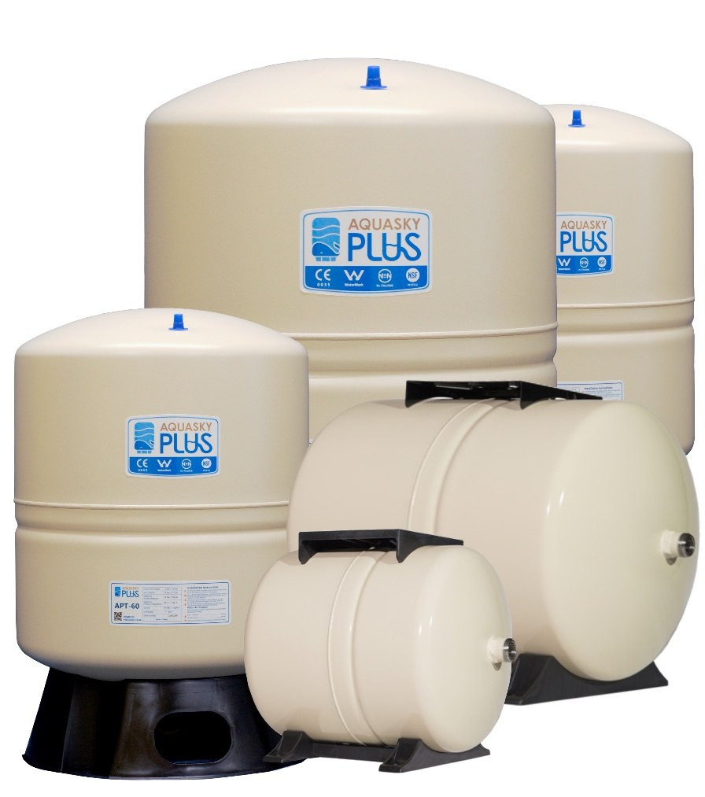

Shell | System Connection | Coating | Diaphragm | Liner Material | Factory Pre-Charge | Max Working Temperature | Max Working Pressure
Cold Rolled Carbon Steel | 304 Stainless Steel Connector | Triple Grade Shield Coating | Heavy Duty Butyl Rubber | FDA Grade Polypropylene | Up to 160LT  =30 PSI 2 Bar  240LT-450LT  =45 PSI 3 Bar | 90 C  194 F | 150 PSI  10 Bar

Sizes Available:
 | 1” BSP Stainless Steel Inlet Fitting |  |  |  |  | 1 ¼” BSP Stainless Steel Inlet Fitting
Vertical | 3LT | 8LT | 18LT | 60LT | 80LT | 100LT | 160LT | 240LT |  | 450LT
Horizontal | 24LT | 60LT

Features Include
Stainless steel nipple fitted on top mounted models.
Stainless steel elbows on free standing models.
Long life diaphragm system with high-grade butyl membrane.
Plastic mounting base.
The shield coating two-part polyurethane exterior over an epoxy undercoating provides excellent protection from UV and salt spray.

 |  |  |  |  |  |  |  | 

